North Carolina

Plant Pathology

NewS

Plant Pathology Society of North Carolina / August 2015
Annual meeting announcment
The PPSNC Board is pleased to announce that the 2015 Annual Meeting has been planned for October 27, 2015 at the Bartlett Research Laboratories in Charlotte, NC.
The title theme for the meeting, “Nematology: Past, Present and Future” will showcase nematology in North Carolina from a variety of presenters. We look forward to seeing you there!
Visit ppsnc.wordpress.ncsu.edu for information and to register!
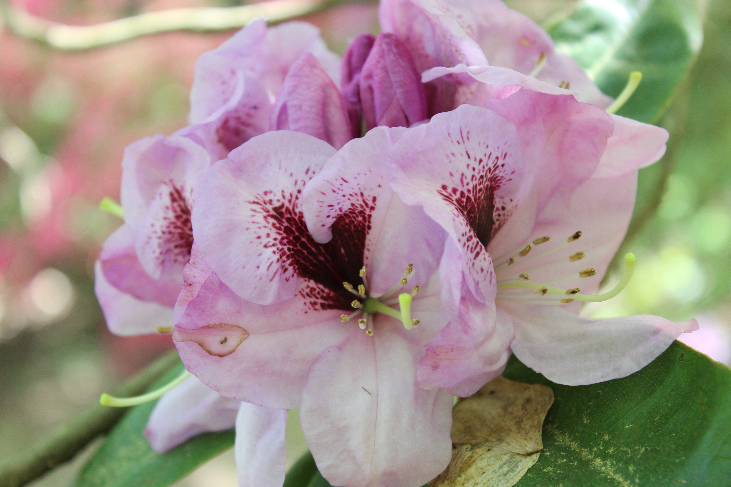
Photo courtesy Andrew Loyd, Barlett Tree

Annual Meeting Host: Bartlett Tree Experts

By Andrew Loyd

The F.A. Bartlett Tree Experts company was founded in 1907 by Dr. Francis Alonzo Bartlett in Stamford, Connecticut. The company’s mission has been built on the foundation of scientific tree care since the founding. In 1927, Dr. Bartlett established The Bartlett Tree Research Laboratories and Experimental Grounds in Stamford, Connecticut and staffed the laboratory with some of the leading researchers from that time period. In 1965, the lab was relocated to Charlotte, NC where it currently resides. The laboratory has four full time Senior Research Scientists who contribute to the scientific community by conducting research in arboriculture or related fields. In addition, the research lab houses a private diagnostic lab, which is recognized by the National Plant Diagnostic Network and serves all of Bartlett’s North American field offices. Continuing to build on Dr. Bartlett’s legacy, the scientific research conducted at the lab today is what drives the company’s business.
In addition to research, the lab grounds in Charlotte takes pride in their plant collection and is recognized as a level IV class arboretum, which is the highest level of accreditation from the Interactive Community of Arboreta. With over 12,500 accessioned plants, the arboretum includes one of the best collections of oak and conifer on the east coast, the largest collection of magnolia cultivars in the world, the third largest collection of holly in the United States, as well as extensive collection of elm, crape myrtle, crabapple, maple, rhododendron, witch hazel, and numerous display gardens. In addition to the collections and research areas, several ponds, natural areas and woodlands are nestled throughout the arboretum to provide a home to a variety of wildlife.
The Bartlett Tree Research Laboratories and Arboretum is actively developed, curated and managed to support learning, discovery, research, and training, and to serve as a resource to the employees and customers of The F.A. Bartlett Tree Expert Company. The arboretum seeks to contribute to and showcase a wide range of plant material as well as set an example of a sustainable, enjoyable, and thought-provoking, living museum. We look forward to hosting the Plant Pathology Society of North Carolina in the Fall of 2015.

Welcoming New plant Pathology Students
Since the publication of the last newsletter, the Plant Pathology department at NC State has welcomed two classes of new graduate students.
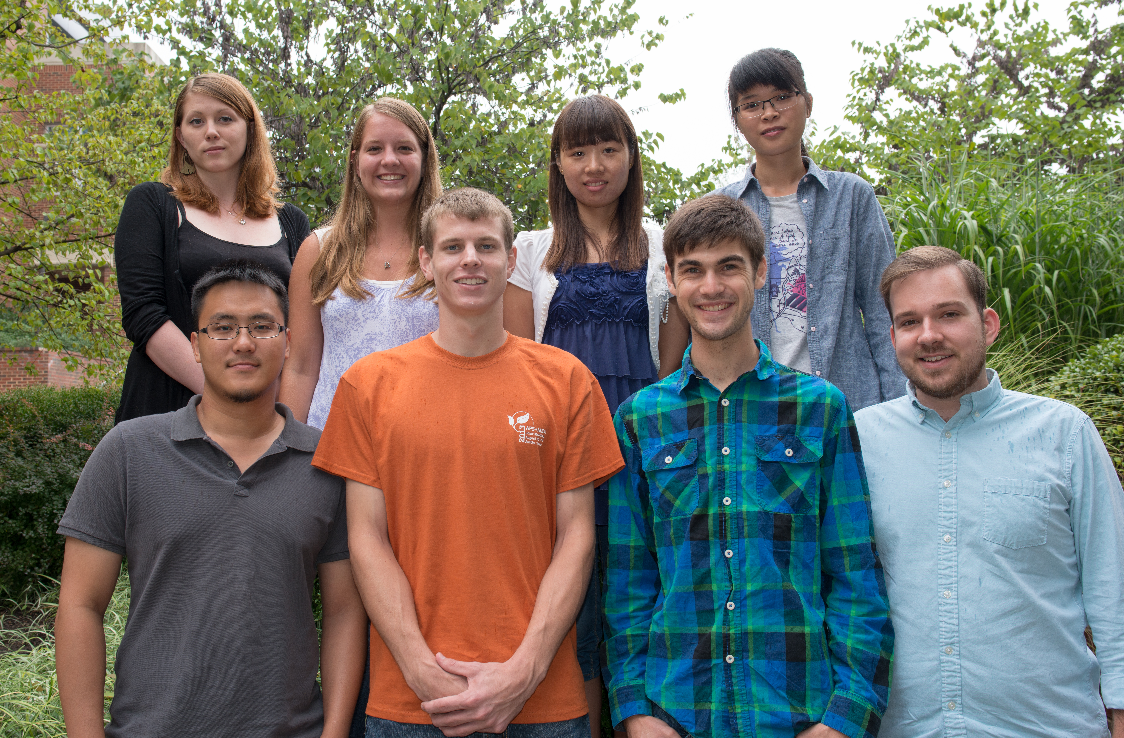
2014 Class

Back row, left to right: Brianna Hoge, Megan Miller, Mengying Wang, Jing Jin Front row, left to right: HT Tseng, Andrew Scruggs, Nathan Miller, Michael Cannon (Photo courtesy Bryan Cody)

Megan Miller received her B.S. in Biological Sciences from Eastern Illinois University. She is currently working towards her M.S. in Dr. Marc Cubeta's lab on the thermal inactivation of the boxwood blight pathogen.
Brianna Hoge received her B.S. in Biology from Rhodes College. She is working toward her Ph.D. under Dr. Marc Cubeta and Dr. David Ritchie. Her project involves a population structure analysis of Colletotrichum fungi which cause Glomerella leaf spot and bitter rot of apples.
Mengying Wang recieved her B.A. from Henan University of Science and Technology in China and her M.A. from the Chinese Academy of Agriculture Science. She is pursuing a Ph.D. degree working on the application of host-induced gene silencing for rice blast control in Dr. Ralph Dean's lab.
Jing Jin received her B.S. in Horticulture from Zhejiang University. She is working towards her Ph.D. through a project on Rhizoctonia solani AG3 target spot isolates in Dr. David Shew's lab.
Nathan Miller received his B.S. degree in Biology from the University of Tulsa. He is working on his M.S. with Dr. Lina Quesada studying chemical management of Fusarium wilt of watermelon.
Andrew Scruggs received his B.S. from North Carolina State University in Horticulture Science. He is working on his M.S. with Dr. Lina Quesada on improving control strategies for postharvest diseases of sweetpotato.
Hsien-Tzer (HT) Tseng received his M.S. in Plant Pathology from University of Georgia. He is now working on a Ph.D. with Dr. Asimina Mila. His project involves management of bacterial wilt through quorum-sensing inhibition.
Michael Cannon received his dual B.S. in Plant Protection and Entomology from the University of Delaware. He is working on his M.S. in Dr. Barbara Shew’s lab on Sclerotinia blight of peanut and assists in the Plant Disease and Insect Clinic (PDIC).
2015 Class
Please join the NC State Plant Pathology Department in welcoming the newest additions to our graduate student group!
Jane Marian Luis received her M.S. degree from the University of Georgia. She will be joining Dr. Peter Ojiambo's lab for her Ph.D. to continue working on aflatoxin management.
Alex Eyre received his B.S. in Molecular Genetics and Biomathematics from Ohio State University. He is working toward his Ph.D. in Dr. Ralph Dean's lab where he is identifying the plant targets of effector proteins secreted by the pathogenic fungus, Magnaporthe oryzae.
Austin Wofford received his B.A. in Biology from Hendrix College. He is working towards a M.S. on a project involving Verticillium wilt on grafted tomatoes in Dr. Frank Louw’s Lab.
Lindsey Becker received her B.A. from The College of Wooster. She is working towards her M.S. in Dr. Marc Cubeta's lab and her project involves investigating the microbiome of Calibrachoa seeds.
Michael Kovens received his B.S. in Biology from Washington College and a M.S. in Plant Science from Missouri State University. He is rotating labs to determine a project he can work towards his Ph.D. with.
Camilo Parada received his B.S. in Biotechnology Engineering from Francisco de Paula Santander University - Colombia. He is working on his M.S. in Dr. Lina Quesada’s Lab. His project focuses on characterizing novel populations of Phytophthora capsici throughout North Carolina.
Julia Heiken received her B.S. in Crop Science from North Carolina State University. She is working towards her M.S. under the Bayer CropScience Fellowship with Dr. Charles Opperman and Dr. Rick Davis. Her project focuses on the effects of fluopyram on plant parasitic nematode populations.
Allison Anthony received her B.S. in Biology from East Carolina University. She is working towards a M.S. with Dr. Jim Kerns and Dr. Ignazio Carbone on a project dealing with dollar spot in turf grass.

Community Outreach Led by NCSU Graduate Students By Kestrel McCorkle
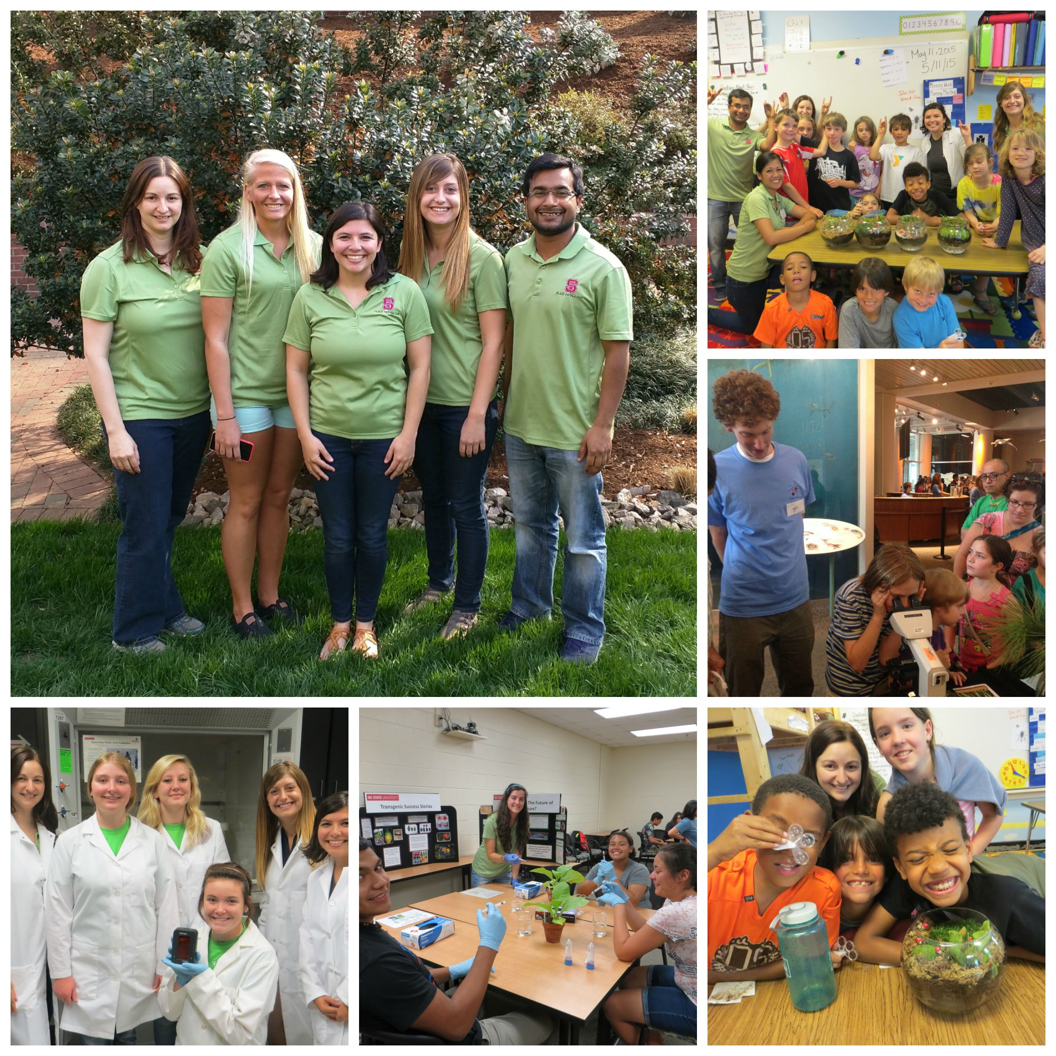
The North Carolina State Plant Pathology Graduate Student Association Outreach Committee formed a few years ago to increase interaction between graduate students and members of the community. Since its inception, the outreach committee has interacted with students of all ages by visiting multiple high school classrooms, master gardener meetings, and science clubs. Members have also attended multiple community outreach events through participation in BugFest and the Triangle SciTech Expo at the Museum of Natural Science in downtown Raleigh. They have shared information on plant pathology, biotechnology, and plant sciences to over 300 students and thousands of people during community events at the museum. Outreach events allow graduate students to share their knowledge and love for the discipline by doing hands-on demonstrations and activities with students. Events have included everything from transferring and maintaining pathogen cultures, infiltrating leaves with bacteria, observing plant disease samples, making slides of fungal structures, observing nature, making terrariums, DNA extraction, gene amplification, and gel electrophoresis.
This past year, they visited the Central Park School for Children in Durham, hosted a group of FFA students, and participated in the Triangle SciTech Expo and BugFest. The outreach group applied and received two grants, one from the Mathre Education Foundation through the American Phytopathological Society and one from the N. C. State Student Government, for $1000 each. With these funds, they were able to purchase new gel boxes for an agriculture biotechnology program they are developing. The new gel boxes were used during a successful trial run of the program this June.
If you are interested in having us present for your group, please contact Emma Lookabaugh at eclookab@ncsu.edu or Kestrel McCorkle at krlannon@ncsu.edu.

Clinic Corner By Mike Munster
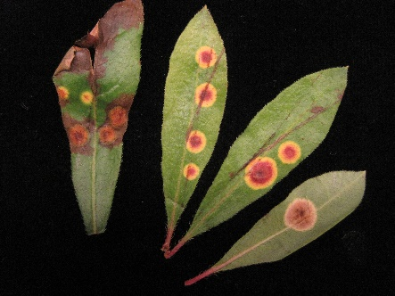
As of August 7, the Plant Disease and Insect Clinic at North Carolina State University has received over 1600 samples for 2015, putting us slightly ahead of where we were at this point last year. The hotter summer has been favorable for certain diseases. But summer is fading, and fall and winter ornamental crops have already started arriving from greenhouse producers of mum, pansy, and even poinsettia.
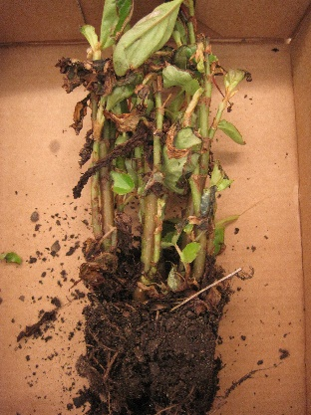
Two of the more interesting recent samples involved basiomycetes. One was a first for North Carolina: white smut of Tradescantia, caused by a fungus in the genus Kordyana. Another was a spectacular leaf spot of deciduous azalea [top right]. The evidence is incomplete, but the best diagnosis is that this is an atypical species of Exobasidium, causing leaf spots instead of galls. You may have encountered similar spots on other members of the Ericaceae.
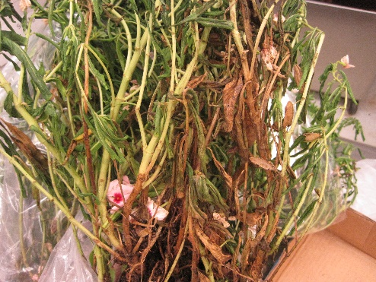
As usual, we see a mixture of the old and the new. The Madacascar periwinkle (a.k.a. “annual vinca”) pictured [bottom right] is a classic case of Phytophthora root rot and aerial blight. A begonia sample [left] was a perfect example of root problems causing leaf symptoms. It has Pythium root rot, Rhizoctonia root rot, and root-knot nematodes. The landscaper is going to have a difficult time finding any bedding plant that isn’t going to have problems with at least one of those pathogens.

New NC State University Faculty

Introducing Dr. Sara Vilani, Assistant Professor of Apple and Ornamental Pathology

As the new extension assistant professor of apple and ornamental pathology, I am looking forward to the opportunity to collaborate with growers and other stakeholders throughout the region to build a successful applied research and extension program at NCSU. My appointment officially begins on December 1, 2015 just in time to escape my favorite winter activities: warming up my car for half an hour and practicing my ice skating skills while “walking” the dogs. Currently, I am nearing the completion of my PhD research in Kerik Cox’s program at Cornell University. My graduate project has primarily focused on elucidating molecular mechanisms involved in practical resistance to single-site fungicides in the apple scab pathogen, Venturia inaequalis. The objectives of my research have been largely driven by my strong desire to help growers, extension personnel, and crop consultants manage apple diseases in an economically and environmentally sustainable manner. While pursuing my graduate degree I’ve also been fortunate to maintain my position as a research technician in Kerik’s program.
My new position will be located at the NCSU Mountain Horticultural Crops Research and Extension Center in Mills River. Being one of the southernmost major apple production regions in the country, I anticipate largely focusing research and extension efforts on what are considered the foliar and fruit “summer diseases” of apple including Glomerella Leaf Spot (GLS) and Bitter Rot which are currently resulting in up to hundreds of thousands of dollars in losses annually. It is my hope to continue and to evolve the highly respected and world-renown apple summer disease program of one of my predecessors, Dr. Turner Sutton. Gaining further insight into the fungal species involved in causing GLS and Bitter Rot and the epidemiology of the disease will be important to improving management paradigms in commercial orchards. Graduate student Brianna Hoge, under the advisement of Drs. Dave Ritchie and Marc Cubeta, has already begun to tackle these questions and has spent countless hours visiting with growers, sampling from their orchards, and perfecting isolation methods. I look forward to working with Brianna, Dave, and Marc and using this information to develop more efficacious chemical and cultural management strategies for this disease. In addition to my apple responsibilities, I’m eager to work with ornamental stakeholders and gain further insight into regional disease concerns. Certainly the threat of Boxwood Blight continues to be a concern throughout the region, so I can envision some of my early efforts in ornamentals being focused towards that direction. Collaboration with the fantastic Plant Disease and Insect Clinic at NCSU to assist in diagnostics of ornamental diseases and providing management recommendations will be a regular component of my extension ornamental program. Aside from work, I cannot wait to explore the beautiful hiking and mountain biking trails near my new home in Western NC!

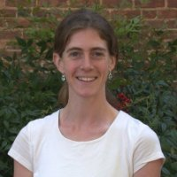
Introducing Igna Meadows, Extension Vegetable Pathologist
Inga Meadows earned her B.Sc. from Oregon State University in Botany with a focus on Plant Pathology and her M.Sc. from Clemson University in Plant and Environmental Science with a Minor in Experimental Statistics. In recent years, she has worked as Mycologist for the Ministry for Primary Industries in Auckland, New Zealand, served as a plant disease consultant, and conducted research in ornamental and forest pathology for Clemson University.
As Extension Associate Vegetable Pathologist for western North Carolina, her responsibilities are to address disease issues on vegetables in the region by providing recommendations for disease prevention and suppression, providing information to stakeholders on vegetable diseases and their management, and supplementing these efforts with a research program that addresses these needs to improve our tools for managing disease. Much of her focus will be on tomatoes, as they represent a large portion of the vegetable production in this region, but she looks forward to supporting production of other vegetable crops and both large and small farms, as well. Her official start date was July 27, 2015 but prior to this date she began meeting with some WNC growers, local agents and industry representatives. She is located at the Mountain Horticultural Crops Research and Extension Center in Mills River, NC and can be reached by email at immeadow@ncsu.edu.

Laboratory SPOTLIGHT: Cowger Lab By Emily Meyers
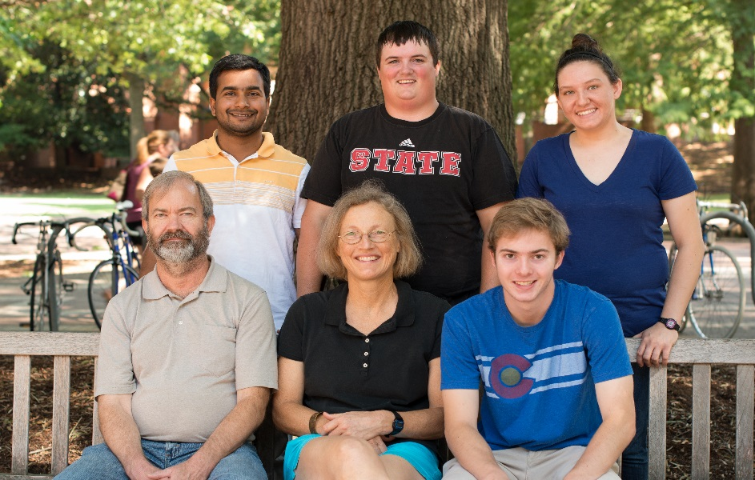
The Cowger lab, housed at NC State, researches diseases of small grains as part of the USDA-ARS Plant Science Research Unit and the NC State Department of Plant Pathology. Current research projects include work with several economically important small grains fungal pathogens:
WHEAT POWDERY MILDEW
A multi-year collection of over 1,000 U.S. wheat powdery mildew (Blumeria graminis f.sp. tritici) isolates is being analyzed to identify population genetic structure both nationally and intercontinentally in collaboration with Swiss researcher Dr. Beat Keller and colleagues in Israel, South Africa, Australia, and China. These isolates are also being utilized to research regional population virulence to commercially important resistance genes, regional population sensitivity to commonly used fungicides, and parameters of isolate aggressiveness. This collection also aids in characterizing new powdery mildew resistance genes for wheat breeders at NC State and collaborating breeders at several other universities.
Back, left to right: Lucky Mehra, Tyler Cole, Emily Meyers Front, left to right: Matt Hargrove, Christina Cowger, Will Ostrom Not pictured: Leslie Williams
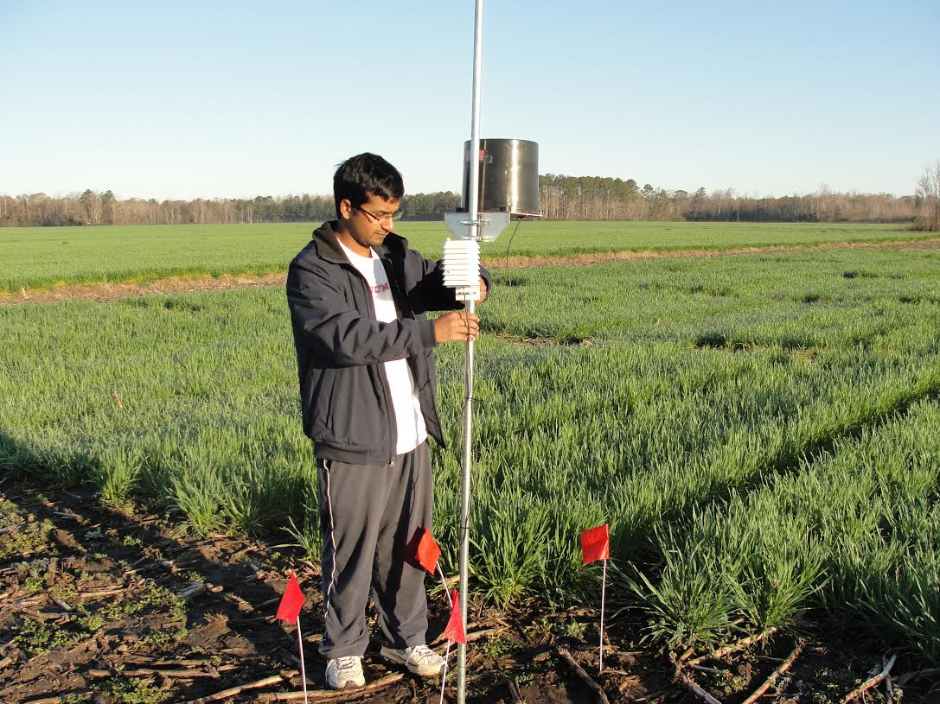
WHEAT AND BARLEY HEAD SCAB
Projects on wheat and barley head scab (caused mainly by Fusarium graminearum) include an economic evaluation of disease management practices as well as a national management survey of 16,000 producers from 17 states for the US Wheat & Barley Scab Initiative. Additionally, 2,200 isolates were collected as a survey of the NC scab-causing population and are being analyzed to better understand toxigenic potential and population variability.
STAGONOSPORA NODORUM BLOTCH
In collaboration with Dr. Peter Ojiambo’s lab (NC State Department of Plant Pathology), work on wheat Stagonospora nodorum blotch (SNB, caused by Stagonospora nodorum, recently renamed Parastagonospora nodorum) focuses on the effects of weather and cultural practices, like leaving wheat residue on the soil surface, on disease severity. Screening for resistance to SNB is also conducted on about 300 experimental entries annually at the major eastern-U.S. wheat breeding nurseries.
Lucky Mehra checks a weather station at his SNB experimental plots in Aurora, NC.
In addition to research projects, Dr. Christina Cowger rates the NC Official Variety Trial for the aforementioned diseases as well as soil-borne wheat mosaic virus, diagnoses samples for the NC State Plant Disease and Insect Clinic, acts as the small grains extension pathologist, and teaches a section of the graduate level host resistance course. Graduate students Lucky Mehra and Emily Meyers work on Stagonospora nodorum and Blumeria graminis f.sp. tritici respectively, while Matt Hargrove, Tyler Cole, Will Ostrom, and Leslie Williams assist with many projects in the lab, greenhouse, and field.

Review of 2014 ANNUAL Meeting By Lisa Ferguson
Date: October 14, 2014
Theme: 100 Years in Extension
Location: USDA APHIS PPQ Center Plant Health Science and Technology, 1730 Varsity Dr, Suite 400, NCSU Centennial Campus, Raleigh, NC
Speakers and agenda were organized by Jim Kerns (NCSU Plant Pathology), with the assistance of the PPSNC executive board. We gathered to interact with our colleagues in plant pathology in NC. In addition to a series of speakers we held a short business meeting to discuss new and old business, elect officers, present the 2014 travel award, and industry updates.
The series of seminar speakers included the following speakers and titles:
Tom Melton, Deputy Director, NCCES and Agriculture and Natural Resources Program Leader ‘The Future of Extension at NC State”
Peng Tian, PhD Student UGA “Characterization of host resistance and Asian soybean rust (ASR) pathogen variability for durable resistance”.
Lina Quesada-Ocampo, Assistant Professor and Extension Specialist, “Improving detection and control of cucurbit downy mildew through research and extension.”
Alyssa Koehler, PhD Student NCSU, “Diversity and Population Structure of Rhizoctonia species in the urban landscape.”
Joseph Roberts, PhD Student NCSU, “Bacterial Fright: A Case Study in Extension and Research Coexistence.”
Liliana Cano, Post-Doctoral Scholar NCSU, “Genome analyses of filamentous plant pathogens.”
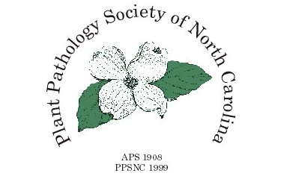
Board of Directors
President
Jim Kerns, NCSU
jpkerns@ncsu.edu

Vice President
Axel Elling, Bayer
axel.elling@bayer.com

Secretary
Mike Adams, NCSU
madams@ncsu.edu

Treasurer
Weimen Ye, NCDA
weimin.ye@ncagr.gov

Industry Representative
Andrew Loyd
aloyd@bartlett.com

Government Representative
Lisa Kohl, UDSA
lisa.m.kohl@aphis.usda.gov

Student Representative
Michael Cannon, NCSU
mdcannon@ncsu.edu

Team Members
Lisa Ferguson
Mike Schwarz
Lorraine Graney
Heather Hartzog
Andrea Lemay

WEBSITE
Please visit the PPSNC website (ppsnc.wordpress.ncsu.edu) for the latest news and information for the 2015 Annual Meeting as it becomes available. The student travel award for the upcoming meeting and information on how to apply will be announced there when it becomes available!

Newsletter Submissions
If you have an idea for an article or would like your group featured in the newsletter, please send your suggestions to Michael Cannon (mdcannon@ncsu.edu).

