**2015 STUDENT TRAVEL AWARD**

**APPLICATION COVER PAGE**

Submit materials *no later than*



**Sept. 18, 2015**



**by e-mail to: mike_adams@ncsu.edu**

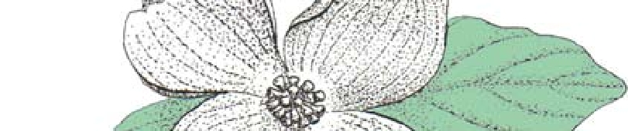

*or* via post to:

**Mike Adams, PPSNC Secretary Department of Plant Pathology Campus Box 7616 - NC State University**



**Raleigh, NC 27695**

**STUDENT NAME:**

**INSTITUTION:**

**ACADEMIC DEPT OR MAJOR:**

**DEGREE SOUGHT:**

**MAILING ADDRESS:**

**TELEPHONE:**

**FAX:**

**EMAIL:**

**SCIENTIFIC MEETING TO BE ATTENDED:**

**MEETING DATES:**

**MEETING LOCATION:**

**ELIGIBILITY STATEMENT**